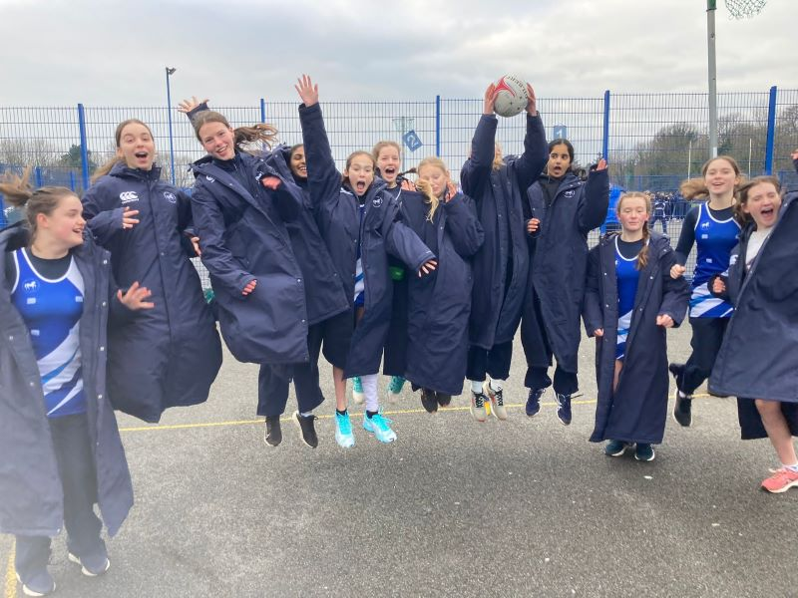

ANNUAL REPORT
2023
Netball South
Website: Welcome to Netball South - Netball South
Chair: netballsouth_chair@outlook.com
Regional Officer: south@englandnetball.co.uk

TABLE OF CONTENTS
Functional Reports 3
Chair report 3
Competitions report 4
Officiating report 7
England Netball report 9
Finance report 15
FINANCIAL STATEMENTS 17
Bursaries 17
Income & Expenditure account 18
County Reports 20
Berkshire 20
Hampshire 21
Sussex 24

Functional Reports

Chair report
My fellow RMB members and TSG officers have again worked relentlessly for the 2022-2023 season making sure our Region is one of the most pro-active across multiple areas including participation, competition, officiating with a Regional Management Board that is organised, passionate and driven to actively promote our Sport and support our members.

Officiating again saw significant increases in the levels of newly qualified umpires across some of the categories and we were recognised as a Region on the National Stage repeatedly at Super league matches. A special mention too, to our youth players who again did our Region proud at the National Clubs and our players across the younger age groups Roses who have been selected into the National academies as well as our main Roses World Cup Squad; they all started their journey with Netball South and credit to the great clubs and Counties that support them on their journey.

Our sport could not achieve what is does without our volunteer infrastructure and I want to personally thank everyone who gives their time for our sport. I am proud to be part of this great TEAM and want to continue our journey to embrace trust, openness, honesty, transparency and foster a culture of ‘working as one’ for the good of the sport.

The main themes we, the Exec team at Netball South with our Counties this year are:
- The Adventure Strategy, underpinning the England Netball Adventure strategy 10-year plan.
- Achieving Tier 1 Governance for our Region and Counties which is mandatory for England Netball (ref: Sport England Sports Governance).
- Delivering the One Awards and Netball Festival Showcase at the Netball South Celebration Event on 17 June 2023.
- A new coaching content area on the Netball South website with material from the New Zealand Programme launching September 2023.

Notwithstanding all the ‘business as usual’ work that goes on behind the scenes in other functions like, finance, officiating, competition, governance, marketing and coach education ;we can’t do this without you, our great volunteers who do put their heads above the parapet and step up.

As you know, we are facing real challenges in our sport due to rising cost of living which knocks on to the sport in a variety of ways including travel, facilities, kit, and we want to ask everyone to think about this and ways we can support our sport to ensure there are no financial barriers to entry; this will include Netball South asking our National Governing Body to review the fee structure on membership and reduce this to assist our sport; Netball South will not be charging their membership element for the 3rd year running.

Finally, I want to thank you, our members who we serve and look forward to another great season of netball.

I could write multiple pages of the work our BOARD does behind the scenes , but I will let you read their reports following to get an idea of what’s being going on; all that remains is to say thank you for having me as your Chair, I will continue to work hard for you if I am re-elected to the post and ensure we remain as proactive and fearless as a Region in dealing with the good and the not so good in our sport; with final special closing thanks to Toni, my vice chair, and Jo, our Finance Director who have been working tirelessly behind the scenes with me on a number of projects this year.

Julie Tucker
Chair Netball South Regional Management Board

Competitions report
Club Competitions:

Netball South conducted a full set of Regional Leagues and Divisions.

The U13 competition was run as a single division comprising of 16 teams. Teams played each other on one occasion.

U14 and U16 divisions ran as two divisions within each following the entry tournament with the top two in division 1 going on to represent Netball South at the National Club Competitions.

The U19 Competition ran as two divisions.

All Open Divisions ran as normal.

There has been a decline in the number of requests to postpone this season. Last season there were 60 requests, this season 27.
Of the 27 requests 22 received were granted.

Results:
OPEN DIV 1
Winners Eagles
Runners-Up Shooting Stars

OPEN DIV 2
Winners Royals
Runners-Up Swan

OPEN DIV 3
Winners MK Netters Ice
Runners-Up Team Matrix

U19s DIV 1
Winners Eagles
Runners-Up Weston Park Blades

U19s DIV 2
Winners 5Ways
Runners-Up Magic

U16s
Winners Eagles
Runners-Up Weston Park Blades

U14s
Winners Eagles
Runners-Up 5 Ways

U13s
Winners Eagles
Runners Up CD Phoenix

Having finished as runners up in Open Div 1 Shooting Stars went on to represent Netball South at the National Premier League playoffs, unfortunately they were unsuccessful on this occasion and remain in Open Div 1.

Royals and Swan promoted to Open Division 1, Clan and Dreams relegated to Open Division 2.

MK Netter Ice and Team Matrix promoted to Open Division 2 with Rushmoor Two and Clan Two relegated to Open Division 3.

Open Div 3 Playoffs
Sunday 7th May saw six teams competing for the two places in the Open Div 3 league, Eagles were the winners and gained promotion for U19s Div 1 and Sussex Lightning maintained their place. (Trinity were unable to maintain their place in Open Division 3 at the playoffs)

U19 Div 2 Playoffs
Six teams also competed for one of three places in the U19 Div 2. Bs, Guernsey and London Falcons were successful and will join the league in the coming season.

5Ways and Magic were promoted from U19 Division 2 to U19 Division 1.

National Results
U14 Clubs
2nd Eagles
6th 5 Ways

U16 Clubs
5th: Weston Park Blades
9th : Eagles
Congratulations to all teams representing Netball South

National Schools

The National Schools Regional Round took place on Saturday 28th January 2023

Regional Results

U14
Winners: St Swithins
Runners-Up: Hurstpierpoint

U16
Winners: Hurstpierpoint
Runners-Up: The Marist

U19
Winners: Wellington College
Runners-Up: Hurstpierpoint

National Results

U14
Cup Competition
1st: St Swithins
3rd: Hurstpierpoint

U16
Finals
3rd: Hurstpierpoint
Cup Competition
3rd: The Marist

U19
Cup Competition
1st: Wellington College
3rd: Hurstpierpoint
Congratulations to all teams representing Netball South.

Looking Forward:
The entry tournaments will be held on 3rd and 4th June in East Grinstead, fixtures will then be published and distributed as soon as possible. The rules will be reviewed and discussed at the Club Forum following teams completing a Google form with their comments and any requests to change rules. We wish all clubs a restful summer and good luck for the coming season.

Jan Johnson
Competitions Director, Netball South
On the behalf of CTSG

Officiating report
NS Open & U19 Leagues
The 2022/2023 has proved extremely challenging from an Officiating perspective. Although the OTSG allocated umpires to the 3 Open Divisions and 2 U19 fixtures, many of the matches had umpires doubling up. The availability of umpires was a concern but my thanks to those who came forward to assist at crucial moments.
Umpire Achievements
Chris Obin was appointed to the Netball Super league group of Umpires. Emma Izon and Emma Walker were awarded a position as Reserve Umpire at Super league matches, to gain knowledge and experience at what is expected at these matches.
Emma Bailey, Hannah Walker, Fran Megson and Marnie Byles attainted their B Award Status as umpires.
Each County in the Region registered several Into Officiating and C Award umpire successes. Let us hope these umpires will now progress to the next level.
Helen Turton was appointed to the U16 National Schools Final, with Erin Graham to the U16 Cup Semi Final.
Rebecca Moher was appointed to the U16 National Clubs U16 Final.
Finally, Emma Walker and Lisa Vallely will be involved with the England Roses in their preparation for the World Cup in South Africa in August.
Technical Officiating Achievements
The following Technical Officials were appointed to the Commonwealth Games in Birmingham – Julie Arnold, Toni Brunsdon, Jo Coker, Sarah Jackson, Jan Johnson, Mary Stanley, Kim Simmons, Tracy Stubbs and Rachel Tanner.
The following were appointed to the 2 Uganda Test Matches in October – Julie Arnold, Sarah Jackson, Toni Brunsdon, Kim Simmons and Tracy Stubbs.
The following were appointed to 2 Jamaica Test Matches in January – Julie Arnold, Toni Brunsdon, Jo Coker, Mary Stanley, Tracy Stubbs and Rachel Tanner.
Jo Coker was appointed by Europe Netball to attend the U19 Event in Northern Ireland.
Jo Coker, Sarah Jackson, Jan Johnson, and Mary Stanley were appointed to the Europe Netball Open Challenge event in Wales.
Julie Arnold, Toni Brunsdon and Jan Johnson were appointed to the Netball Super League Finals.
We are very strong in the South with our Technical Officials, and it is good to see that a majority are being selected for National and International matches.
Netball South are responsible for appointing TOs to the NSL at Surrey Storm and London Pulse, and we have a good group of other TOs who support these franchises as well.
We have also supported Eagles Netball Club in their first season in National Premier League Division 3.
Courses
All umpire courses are now run online by England Netball. I know the Counties have faced a huge task in getting assessments organised for Into Officiating and C Award.
There has also been new Assessor Courses held, again online by England Netball, and we have a fair number of new Into Officiating Assessors now in the Region who are beginning their Assessing pathway. Once they have completed their obligatory number of assessments, they will move on to becoming C Award Assessors.
Regional Schools
The Regional Schools were held in January and was well supported by umpires within the Region with the following appointments were made by the Court Mentors on the day:
U19 – 3rd/4th play off – Jill Allington/Suzanne Haley
FINAL– Channon Heaney/Emma Izon
U16 – 3rd/4th play off – Clare Kitchen/Stacey Boxall
FINAL – Ellie Balchin/Emma Walker
U14 – 3rd/4th play off - Ben Vallely/Becci Dick
FINAL – Megan Pratt/Sam Sear
Inter Services Championships
The following umpires/officials supported the UK Armed Forces at their Inter Services Championships at RAF Cosford:
Emma Dell, Julie Arnold, Mary Stanley
Regional Tournaments
Various umpires were appointed to the Regional Schools, Regional Division 3/U19 Play Offs and Junior Entry Tournaments. There were a lot of new faces mixing with the more experienced umpires. Court Mentors were appointed to all 3 tournaments, and I thank everyone for their support.
Finally, I thank all members of my OTSG for their continued support, enabling Officiating within the Region to run smoothly.

Julie Arnold
Officiating Director, Netball South
On behalf of the OTSG:
Tracy Stubbs
Julie Wilks
Rachel Hammond
Alexia Bolton
Carol Williams

England Netball report

Firstly, we would like to extend a huge heartfelt Thank You from England Netball to each and every Netball South Member for your continued support, passion and dedication you have shown for our wonderful sport throughout 2022/23.

England Netball Priorities for 22-23 were:
We are working on the Foundation stage of the 10-year Adventure Strategy. Two of the key areas for the Development Department are around “A Game For Life” and “A Thriving Collective”
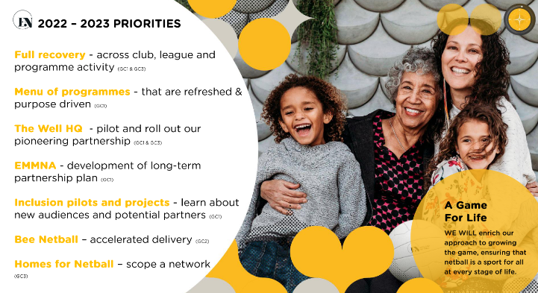


National highlights:

Funding - Sport England shared the news that £21.2 million has been awarded to England Netball in the latest round of Sport England funding to support the delivery of both our ‘Adventure Strategy’ and Sport England’s 10-year ‘Uniting the Movement’ strategy. Over £550 million has been invested in total with partners like us receiving funding for the next five-year cycle.

Inclusion - 26 September to 2 October was National Inclusion Week, we supported a deaf netball tournament in Derby at the Woodlands Sport and Leisure centre, welcoming players of all abilities – from regulars to beginners - to take part in a fun day of netball as we look to expand our reach to participants in this area.
For Black History month in the lead-up to and during the Uganda series, we implemented the #MyNameIs campaign with phonetic spellings of player and staff names into our event programme and commentary notes, to highlight the importance of people’s identity and heritage.
We took part in the Pride in London parade on Saturday 2 July 2022 in support and plans in place to do-so for the upcoming event this year.as part of our ongoing commitment to our moral compass and being Dedicated to Difference.

Comm Games – Despite a disappointing 4th place, there were many positives to take from the Commonwealth games.150,000 tickets were sold for the netball sessions and a new generation of netball fans will have been inspired by what they saw from the Roses and the world’s best netballers.
Off court, our efforts through our legacy activations and everyone’s hard work to capitalise on the Games are there to see. Over 12,000 people engaged in our ‘Fan Park’ and ‘Have a Go’ activations meanwhile hundreds of fans took advantage of our watch party events.

Bee Netball - The relaunch of our Bee Netball programme featured 50 trailblazer clubs delivering sessions to 5-9-year-olds across the country starting the week commencing 26th September.
ChangemakeHERS - As part of how we embed our moral compass, we sought new people to join our Changemaker groups. A Changemaker is anyone who's got the ambition to make change, whether that be big or small. We have a range of groups who through their areas, share ideas and discuss ways as how we as a business can make an impact.
NETBALLher - In 2019, as part of nationwide consultation for England Netball’s new 10-year Adventure Strategy, it was strongly felt that the national governing body should act beyond the court to support women and girls at every life stage and every life age.
Working with The Well HQ, the female health experts, with funding support from Sport England, the NETBALLHer movement will enable everyone in netball and beyond, to better understand, nurture and support women and girls.
This pioneering new movement will support women and girls in a way no other sport has done before. We have created a myth-busting website, filled with a host of interesting and insightful articles and videos. This has now been made available to all members to go on to and start exploring the expert resources we have collated on topics including pelvic health, menopause, the menstrual cycle and bras and kit. Visit the website here.
National Players Association - We announced a three-year partnership with the Netball Players Association (NPA) which will see us work collectively to promote and develop netball at the elite level. The NPA was formed five years ago to provide a unified player voice supporting and promoting player welfare in the UK. This agreement with the NPA recognises the importance of players as stakeholders in the future development and professionalisation of netball.

Tournaments and events:
- National schools - We hosted the annual National Schools tournament at Oundle School in Northampton. After qualifying through the county and then regional rounds, the top 18 teams at U14, U16 and U19 went head-to-head in a two-day competition supported by principal partner’ The British Army and Dynamik Sports Flooring who supported the day’s event.
Thank you to everyone who helped to put on such a brilliant event – it was great to see many of you there and to see how much the teams enjoyed the weekend. Read more and see which sides came out on top here.
- Uganda test series – A three match test series against the She Cranes took place in January 2023 with debuts from Alice Harvey, Olivia Tchine, Funmi Fadoju, Zara Everitt and Ellie Rattu to help secure a 3-0 win
- Australia test series – Despite losing the series to Diamonds 3-0, the Roses battled hard against the World number 1’s throughout, only losing by a nail-biting single goal in the first game, 6 in the second and 4 goals in the third.
- Jamaica test series – The Roses secured a 2-1 victory against the Sunshine Girls. In a highly anticipated battle between 3rd and 4th world rankings, it went down to the wire with the deciding 3rd game.

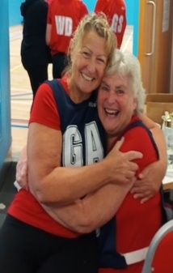
Regional Highlights:

Hampshire sustainable WN sessions - Working with Eastleigh Borough Council, in line with New Year Boost, we started a brand-new programme at a brand-new facility in Hiltingbury called Hiltingbury Sports. It has come full circle with one of the participants now a WN host leading on the session herself. It attracts new ladies regularly, consistently seeing 10-16 participants each week. Since it’s inception it has engaged 25 NTN ladies, 1 of which is a qualified WNHT, with others booked onto future courses. They have set up their own bank account and some have become members. A few are taking a break due to medical reasons but hope to be back with the group soon.

Regional NYCs – NYCs have been a huge success this year. In total 19 NYCs were delivered, bringing in £12,350 of which £9604 was surplus and 341 participants. This averages out at £500+ surplus and 18 participants at each NYC. However, many of these were sell outs.
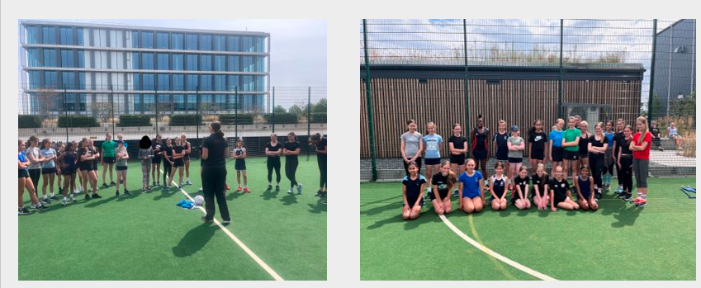Photo from Berkshire NYC

Sussex LSEG Bee netball - A successful partnership was set up with a local charity run by a netball lover who had received 2.5k funding from local source and wanted to spend on netball for youngsters in the local community. They had just had a new court built with junior posts Pilot project was given green light to deliver the following: 19 weekly sessions after school for the local community 2 hour sessions in half term with first taster session Feb 22. 40 children 7-11 years from B&H have attended 25 kids at the taster Average of about 9 on Mondays 34 girls 6 boys 11 from 20% most deprived = 27.5% 9 of which are from the 10% most deprived = 22.5%

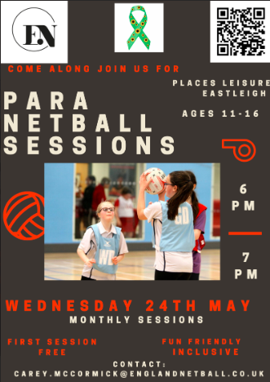
Pioneering core inclusive club - Ravens netball club will become the first core inclusive club in the South region. Sessions will start on May 24th and will cater for ages 11-16 years for these with additional needs, SEN , disabilities etc. Have linked with the Active Partnership and local LA to hopefully make this a huge success. There will be a session a month and we hope to hold a SEN or similar festival in December sometime.

KEY PERFORMANCE INDICATORS FOR THE FUNCTION:

Membership | ENgage | 2021/22  O18 – 7611  U18 – 2410  U14 – 3438  U11 – 2633  Total – 16,092 | 2022/23  O18 – 8088  U18 – 2431  U14 – 3719  U11 – 3371  Total – 17,609 | Variance  O18 +477  U18 +21  U14 +281  U11 +738  Total +1517
Learning & Development | Virtual courses delivered Nationally:  Athlete Identification – 5  Games Sense Workshop – 5  INTO Officiating – 85  C Award Officiating – 27  Level 1 Coaching – 44  Face to face courses delivered across the Region:  B Award Officiating – 1 – Sussex  Level 2 Coaching – 3 – Sussex & Hampshire  Walking Netball Host – 1 – South Bucks
Regional Participation | The team of NDOs and NDCCs have had a great year of recovering (post pandemic) and growing the number of programmes offered across the region in order to re-engage existing participants and grow the sport.  A total of 206 programmes with 3,898 participants taking to the court to play netball saw the team overachieve their annual target (annual target 3,250), The table below shows the total number of programmes and number of participants engaged for the 22/23 financial year.

Number of Programmes & number of participants
- Please note Participation figures are for period: 1st April 2022 – 31st March 2023
Programme | Number of Participants
Back to Netball | 981
Netball Festivals – B2N and WN | 712
Netball Now | 716
Walking Netball | 561
Netball Youth Camps | 330
Junior Netball & Bee Netball | 230
Blended and Disability Netball | 30
Others including School Games | 338
There has been no change to the NDO/NDCC structure for Netball South and each County still has a England Netball member of staff to support the County, Leagues and Members.

KEY RISKS/ISSUES:

WHAT IS RISK/ISSUE | MITIGATION | BY WHOM? | BY WHEN? | NOTES
Staff retention | Core funding from Sport England confirmed February 2022 to allow for permanent staff contracts to be issued | EN | February – April 2022 | N/A
Governance Tier 1 compliance | NS working with EN and Counties to complete Governance Health checks and submit core documents | RMB and EN | As soon as possible (deadline surpassed) | NS support to counties has been offered and documents shared
Registered Leagues at Risk | National EN staff (Club & Leagues and Membership) working with local EN staff (NDO) on league support package | EN | Sept 2023 | EN to work closer with regional to identify support
Cost of living crisis and the impact on participation | EN Pricing Policy  Partnership working with potential funders and facilities to reduce costs. | EN | Ongoing | N/A

NOTABLE EVENTS POST 30th Apr 2022

- NSL Grand final – Copperbox – June 11th 2023
- NWC 2023 Squad announcement and preparations – May – July 2023 in preparation for the NWC taking place in South Africa between 28th July – 6th August 2023
- Netball South One Awards – total number of nominations record for NS (82)

Regional Staff contacts

Partnership Manager:
Amy Stewart | Partnership Manager South & South West | 07872400739 | Amy.Stewart@englandnetball.co.uk
Regional Coordinator:

Lucy Cusack | Regional Officer | 07540127404 | South@englandnetball.co.uk

Regional Office address:

England Netball, Netball South, Bisham Abbey National Sports Centre, Bisham, near Marlow, Buckinghamshire, SL7 1RR
01628 478985
http://www.netballsouth.co.uk/
Amy Stewart
Partnership & Delivery Manager South & South West
England Netball

Lucy Cusack
Regional Officer, South
England Netball

Finance report
KEY HIGHLIGHTS FOR TIME PERIOD – 1 May 2022 - 31 Apr 2023

1. Zero membership Fees charged 01.08.2022 to 31.07.2023
2. Savings Bank Account changed so higher interest rates of up to 1.42%
3. New bank account opened ready for new Financial Year once RMB structure in place
4. Continued understanding of expenditure as cost codes continue to grow as and when something new arises
5. Expenses process included a monthly payment process and is working well.
6. Bursary Policy and structure was put in place in 2021 and you will see on the financial report the value which was supported in 2022/2023

KEY PERFORMANCE INDICATORS FOR THE FUNCTION:
KPI | HOW TO MEASURE | TARGET | ACTUAL | VARIANCE
- n/a | n/a | 100 | n/a | 0

KEY RISKS/ISSUES:
WHAT IS RISK/ISSUE | MITIGATION | BY WHOM? | BY WHEN? | NOTES
New bank account opened and once RMB structure put in place for 2023/2024 will be used. | Reduce admin | JC | 01.10.2023 | On Hold
Expenses policy and procedure review |  | JC and Directors of TSG’s | 31.08.2023 | Discussions to be had

NOTABLE EVENTS POST 31st Apr 2023

- Proposed zero membership fees for 2023/2024 season to RMB so this will be proposed at AGM for all Members who have voting rights to vote
- Continued improvement of financial reporting compared to previous year with correct allocation of expenditure relevant to Technical groups so that we can adjust for future years and ensure ALL members receive the benefit of Netball South Financial aide
- Continue to look at better banking facilities to reduce the amount of administration needed and for better interest rates on savings

Jo Coker
Finance Director, Netball South

FINANCIAL STATEMENTS

Bursaries
2021/2022 | Level 1 | Level 2 | Level 3 | Facilities | Other | Officiating | Competition | Total
Applications Received | 0 | 9 | 2 | 1 | 6 | 0 | 6 | 24
Applications Approved and Funded |  | 4 | 2 | 1 | 6 |  | 6 | 19
Value Funded |  | £670.00 | £1,058.50 | £827.00 | £2,000.00 | £0.00 | £2,100.00 | £6,655.50
Applications Rejected |  | 2 |  |  |  |  |  | 2
Applications Awaiting Further Proof or Reports |  | 3 | 0 | 0 | 0 | 0 | 0 | 3
Value Potential |  | £354.00 | £0.00 | £0.00 | £0.00 | £0.00 | £0.00 | £354.00
2022/2023 | Level 1 | Level 2 | Level 3 | Facilities | Other | Officiating | Competition | Total
Applications Received | 0 | 4 | 0 | 2 | 1 | 0 | 18 | 27
Applications Approved and Funded |  | 3 |  |  |  | 2 | 18 | 23
Value Funded |  | £468.00 |  |  |  | £432.00 | £7,000.00 | £7,900.00
Applications Rejected |  | 1 |  | 1 | 1 |  |  | 3
Applications Awaiting Further Proof or Reports |  |  |  | 1 |  |  |  | 1
Value Potential |  |  |  | £1,000.00 |  |  |  | £1,000.00

Notes:
1 x Level 2 Application rejected as Bursary was 85% funded by another source
1 x Assistance with Academy Fees - also applied to Sussex County - no further information received
1 x Facilities (Posts and Protectors £700), not actually purchased and had not applied elsewhere for funding
Potential:
East Grinstead Sports Facility - waiting on update from Sussex County and or League - new proposal to be submitted as courts are now bring used

Income & Expenditure account
Unaudited as of 1/6/23
Awaiting accountant sign off
 |  | Y/E
INCOME | 30.04.2023 | 30.04.2022 | 30.04.2021
Affiliation
England Netball (Schools and Colleges) | 15 | 249 | 320
Competitions | 36765 | 35218
Officiating | 650 | 455
One Awards |  | 74
Performance
Governance
Media & Marketing
Other (Interest & Misc.) | 725 | 369 | 136
 | 38155 | 36365 | 456
EXPENDITURE
Management Committee | 2137 | 779 | 383
Competitions | 37274 | 35596 | 3097
Virtual League |  |  | 258
Officiating | 1741 | 663 | 174
Performance |  | 66
Governance
Media & Marketing | 432 | 510
Bursaries | 7900 | 6655 | 145
One Awards | 682 | 1337 | 2249
Refund |  |  | 65
Other | 867 | 256 | 796
 | 51033 | 45862 | 7167
Profit (Loss) for the Year | -12878 | -9497 | -6711
Reserves B/F | 143022 | 152519 | 159230
Adjustments
Reserves C/F | 130144 | 143022 | 152519
Savings Account | 132500 | 144515 | 108211
Current Account * | -2446 | -1493 | 44308
Total Reserves | 130054 | 143022 | 152519
* NOTE: Current Account minus due to back dating of late expenses for financial year

Definitions:
Management Committee: Cost of regional management meetings, general expenses, travel expenses for attending EN meetings.
Competitions: Cost and expenses with managing the regional competitions, including meetings, travel expenses, venues, prizes and officiating expenses where the Region allocates officials.
Officiating: Cost and expenses with managing the OTSG, including meetings, travel expenses and mentoring
Bursaries: Expenditure associated with bursaries awarded by the RMB.
ONE Awards: Expenditure associated with 2022 One Awards Celebration Event
Other: Other expenditure not associated with any other categories

County Reports

Berkshire
Berkshire Netball Report 2022/23 Berkshire has enjoyed another successful year due to the work of all the amazing volunteers in the clubs and leagues throughout the County and on the Board. .

Highlights are as follows:
- Berkshire Junior Netball League was once again a huge success with teams from across Berkshire and beyond enjoying regular matches at various venues across the county. This year saw the introduction of the new U19 league the winners of which went on to win a place in the regional league for 2023/24. Kate Maxfield, worked tirelessly together with her sub-committee to ensure that so many young players had the opportunity to compete on a regular basis.
- In addition to the winter league, a friendly summer league also took place at various locations to give teams the chance to keep playing regular netball.
- Berkshire Netball’s U13 & U15 PDPs for our talented youngsters ran at St Neot’s School, Eversley and Wellington Health & Fitness Centre, Crowthorne. Christina Turton-Berenger, Tina Wood, Kate Maxfield, Marina Bowles, Georgie Maxfield, and Sarah Feast. A number of Berkshire U15s were selected for the U15 Surrey Storm School Games programme and the U17 NPL and PDP squads.
- Berkshire’s Performance Lead, Sarah Feast, continued to sit on the Surrey Storm Talent Management Group.
- Berkshire Netball continued to support coach development within the county with bursaries for a number of Level 2 coaches from various clubs.
- Berkshire’s Umpiring Secretary, Mary Stanley, oversaw the development of many umpires within the county. There was a significant number of aspiring young umpires who attended the online Into Officiating courses and have subsequently passed their practical assessments. Many of them gained experience and were mentored at the Berkshire Junior Netball League matches during the winter and summer.
- Berkshire’s NDO, Debbie Spindlow, provided excellent support to the Board as well as delivering her own work programme within the county. She organised a number of EN netball programmes within the county e.g. Walking Netball, Back to Netball. She also organised a tournament for teams whose players are not currently part of a competition squad.
- Berkshire School Games Netball Finals were organised by Debbie Spindlow with support from Berkshire Netball (Sarah Feast) on the day along with Michel Mayne, Chloe Phillips and Christina Turton-Berenger who mentored the young umpires from Newlands School.
- Berkshire clubs and schools were once again very well represented at national finals of their respective competitions with Eagles going through from the Netball South competition in both U14 and U16 age groups to National Club Finals and The Marist representing the region at U16 and Wellington College at U19 age groups at the National Schools Finals.
- Berkshire officials have been heavily involved with the VNSL this season fulfilling roles as technical officials/umpires etc. with some of them being selected for the semi and finals at The Copper Box.
- Eagles Netball Club won promotion from Div 3 to Div 2 in their inaugural season in National Premier League as well as winning Div 1 and U19 in the regional league and taking a place in Div 3 regional at the play offs.
- Royals Netball Club won a place in Div 3 regional league at play offs as well as winning promotion from Div 2 to Div 1 of the regional league.
- Bs won a place in the regional U19 league for the 2023/24 season. Thank you to everyone involved with netball in Berkshire and to all the amazing people who help to make all of this happen.

Sarah Feast
Chair Berkshire Netball Association

Hampshire
This year we have spent a lot of our time developing our governance and reaching the expectations of Tier 1 for governance. This is an ongoing and ever developing requirement of EN to ensure that as Counties we are supporting them to receive their funding from Sport England. As part of this we have had to review how we do things, our risk maps, our skill set and many other processes and documents. This has been cumbersome on the Committee, and I would like to thank all for doing this and the required training that we have had to complete as well. As part of our aim to drive up participation in our committee and in how we do things we advertised for our new Technical Support Groups recently. These are a great way to be involved and influence Netball in Hampshire without having to be on the Committee. We were disappointed that the number of applications was only 2 who were for the Officiating TSG only. We will be re advertising these again hoping to get more interested applicants and would ask anyone interested to contact me. The coming year we need to now focus on our strategy linked to England Netball Adventure Strategy and this will be worked on over the coming months. In addition, we will be reviewing our constitution and our policies including our bursary policy to see how we can make it easier for individuals to apply. What have we been doing this year – we have concentrated on consolidating our leagues and looking at how we can improve and develop these – adult and junior. We continue to look to improve these and will be having more forums with teams and umpires in the coming weeks.

FINANCE - Bursaries have been awarded this year as per our criteria. Our affiliation fees have been reduced to £0.50 per Adult and Zero per junior for the forthcoming season to assist out members in the current economic climate.

LEAGUES - The 2022-23 season has run smoothly for both the Seniors and Juniors, with all netball back to normal. Again, we were not able to allocate umpires this season but still aim to do this. Shooting Stars won Division 1 and represented Hampshire in the play offs for Regional Division 3 but were not successful. In the playoffs to enter the Hampshire League the Army were successful and will be joining us next season. We continue to run the County Schools tournaments and are working closely with the schools for next season.

UMPIRING - This year for the Hampshire Open League it proved impossible to allocate umpires due to only a small number committing to dates All teams sourced their own umpires and if there is more availability of umpires it is anticipated that this might happen next season. HNA held a forum with umpires and one of the discussion points was the varying amounts that umpires ask to be paid and teams are paying Umpires. The group that attended the discussion suggested that £20 / £25 was enough but also that umpires wanted to do 2 matches, if possible, at the same venue. This continues to highlight the need for us to push forward with a central venue or maybe 2 venues which we have been working on this year. Unfortunately, this has not been successful, but we are still going to push on with trying to source this. Assessments continue to be slow but from the 1 May 2022 to 31st April 2023 we had 19 new C Award umpires and 29 umpires passing they’re into officiating award. We continue to hear from leagues and individuals that they are struggling to get onto courses, and we are supporting them as far as we can.

SCHOOLS - This year our competitions were held on a Saturday as last year, but we had to split the age groups for umpiring and organisational reasons. The contribution of the Hampshire Netball Committee is valued highly and we would not have such a successful competition without their kind donation of time. The management and communication, with everything going centrally through League Administrator and Honorary Treasurer seemed to work more effectively and we have had some further contacts through the Facebook group since for next year.
The eventual winners and runners-up were:
- Churchers and St Swithun’s (U14)
- Portsmouth High and Farnborough Hill School (U16)
- Barton Peveril and St Swithun’s (U19).
They progressed to the Regional finals on 28th January, with St Swithun’s (U14) progressing to Nationals. We will be following a similar pattern to last year, in that all schools will be invited via their school admin office, so that no schools are missed. There will be a tight timeline for entry and payment to ensure that all costs are equal and paid on time. Umpiring for the U14 & U16 will be managed centrally by Hampshire Officiating Secretary and teams in the U19 competition will provide their own umpires. The provisional dates for the National Schools- Hampshire County round is Saturday 7th October, 2023 and we will be putting the U19 back to a Wednesday afternoon on 11th October, 2023 (tbc)

PERFORMANCE DEVELOPMENT PATHWAY - This year has been a very successful one for the Hampshire PDP. Following the new guidelines from England Netball both the U13 and U15 age groups have been restricted to 20 athletes. Attendance has been excellent and the new programme has benefitted from some new initiatives.

We have included more sports science in the programme with weekly s/c sessions and talks on nutrition and injury prevention. The athletes (and parents) have appreciated this.

Match days have been included in the programme with Hampshire, Berkshire, Surrey counties in addition to Surrey Storm hosting. This is beneficial for all involved.

ATHLETES - Currently 5 athletes are in the Surrey Storm U15 long squad. Hopefully some of these will make the final selection and be included win the SS U15 squad that competes in the school games against the other franchises.

MEETINGS - Parents meetings have been held at the start and finish of the academy. These have explained the pathway and the role Hampshire PDP plays in this and the options for the athletes moving forward. Coaches from junior clubs were invited to attend a session to gain better understanding of the selection process and to view the standard of the athletes who were currently in the academy.

FEEDBACK - All parents/athletes were sent a feedback questionnaire to complete. The results were very encouraging and show that on the whole the parents and athletes are very satisfied with what we are doing. A more detailed breakdown, with any actions for improvement, will be completed in the coming weeks

COURSES - We have been lucky enough to gain free places on the Athlete Identifier Workshop run by England Netball. Once completed this will mean that we can call upon more people to attend trials as Selectors.

Finally, I would like to thank the Hampshire Committee who give so much time and effort to this league and organisation. The team continues to do all they can to provide brilliant opportunities for athletes and those taking part in all aspects of this sport. We are a very small group of volunteers and are always looking for more people to join our committee.

Carol Williams
Chair Hampshire Netball Association

Sussex
While thanking all the committee for their continued dedication and volunteer hours, particular thanks goes to Lindsay Sartori for all her work drafting a new constitution and completing much of the governance paperwork. Without her input Sussex would not have completed this with knowledge and expertise.

Key highlights:
- Sussex U15 performance pathway squad champions at this years National County competition.
- 5 umpires attending the assessors course to enable the county to recruit/qualify more umpires. Those qualified this year was very low due to the lack of assessors.
- New Sussex County League for u12s, u13s and u15s.
- Continuation from last years state school cup tournament. Great attendance, in the hope that these schools will enter the county round of the National schools tournament in the coming year.

Key issues:
- Many of our regional clubs needing coaches across the age groups.
- Finance for those clubs needing to travel to away regional fixtures. In particular junior teams needing to fly to a game, which requires a higher adult ratio. The county can only offer limited support with the increasing number of teams making these journeys throughout the year.
- Volunteers (who have given many years of their time) unable to continue and therefore recruitment of new volunteers is essential.

Helen Willard
Chair Sussex Netball Association

